**Lab Exercise – 3**

**Name:** Hannah Jeni Sweetline

**Entrollment No:** 232MCAN0046

**Department:** MCA

**Subject**: RDBMS Lab

1.Create a PL/SQL procedure, which receives employee number as input and displays employee name, designation and salary. Call the procedure from the SQL command line.

**Output:**

**Table creation:**



**Insert values:**

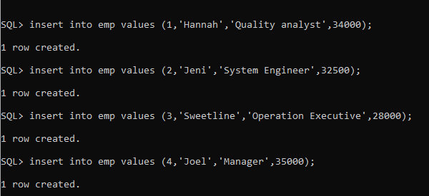

**PL/SQL procedure:**

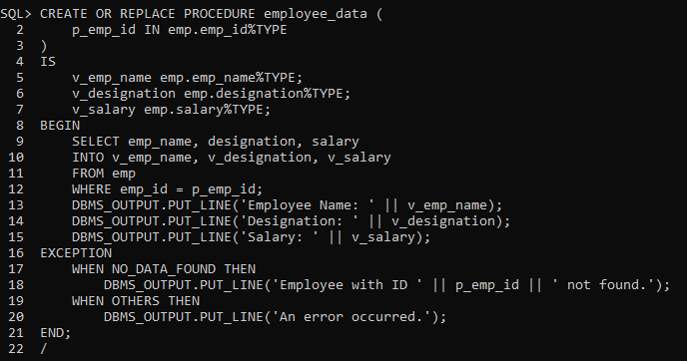

**SQL Command line:**

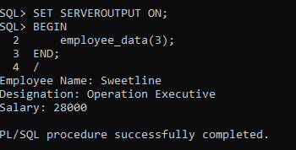

2. Create a PL/SQL function which takes department number as input and returns the location of the department. Call the function from the PL/SQL code.

**Output:**

**Table creation:**



**Insert Values:**

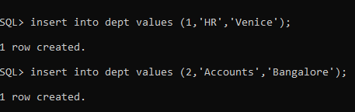

**PL/SQL Procedure:**

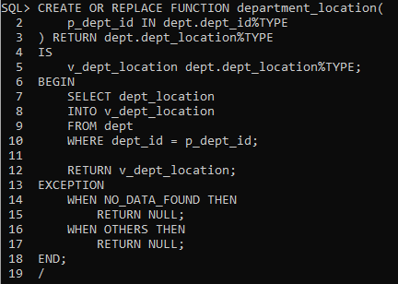

**SQL Command line:**

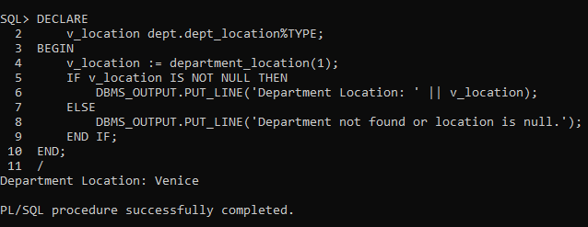

3. Write a PL/SQL procedure that gets department number as input and displays the maximum, minimum and average salary of that department. Call the procedure from SQL command line.

**Output:**

**Table creation:**

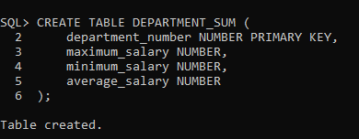

**Insert values:**

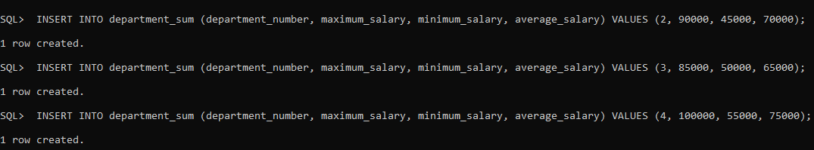

**PL/SQL procedure:**

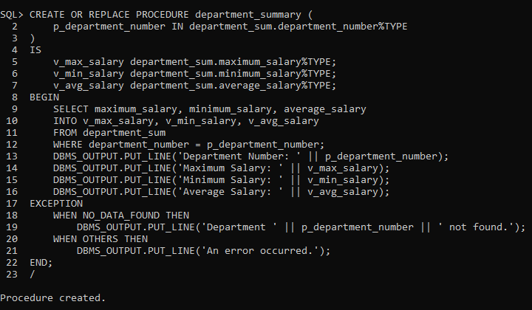

**SQL Command line:**

